for-eachpage break
Employee: fld_EMPLID
Company: fld_COMPANY
Name: fld_NAME
Job: fld_JOBTITLE

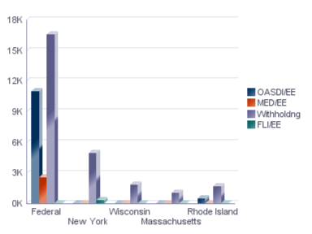

end

